Workshop on “Understanding and Modeling Environmental and Climatic Changes – Challenges and Opportunities”
「環境與氣候變遷的研究-挑戰與機會」研討會
主辦單位：中央研究院環境變遷研究中心
日期：2007年6月13日（週三）● 時間：9:30-17:00 ● 地點：中研院地球所2樓演講廳
報名表（報名截止日期2007年6月6日）
聯絡人  姓名 |  |  | 單位 |  |  | 職稱
電話 |  |  |  | E-Mail
職稱/  年級 | 參加人員姓名 | 用餐  與否 |  | 職稱/  年級 | 參加人員姓名 |  |  | 用餐  與否
 |  | □ 否  □ 一般  □ 素食 |  |  |  |  |  | □ 否  □ 一般  □ 素食
 |  | □ 否  □ 一般  □ 素食 |  |  |  |  |  | □ 否  □ 一般  □ 素食
 |  | □ 否  □ 一般  □ 素食 |  |  |  |  |  | □ 否  □ 一般  □ 素食
 |  | □ 否  □ 一般  □ 素食 |  |  |  |  |  | □ 否  □ 一般  □ 素食
 |  | □ 否  □ 一般  □ 素食 |  |  |  |  |  | □ 否  □ 一般  □ 素食
 |  | □ 否  □ 一般  □ 素食 |  |  |  |  |  | □ 否  □ 一般  □ 素食
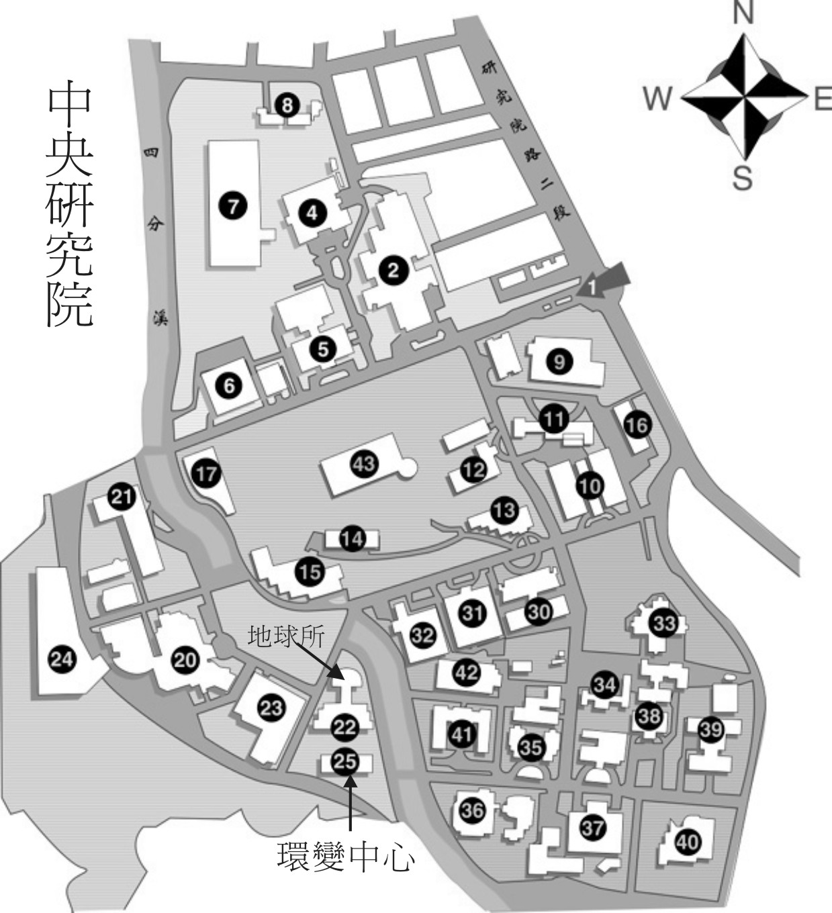
聯絡人：張玉婷
電話：02-26539885轉250

報名方式： 傳真：02-27833584
或電子郵件信箱：nellie@gate.sinica.edu.tw

Workshop on “Understanding and Modeling Environmental and Climatic Changes –
Challenges and Opportunities”
Date: June 13, 2007 (Wednesday)
Location: 2nd Floor Lecture Hall, Institute of Earth Sciences, Academia Sinica
Organized by Research Center for Environmental changes, Academia Sinica

Introduction
The fact that the environmental and climatic conditions on Earth are changing at a significant rate is undeniable. The contribution of human activities to these changes and the role that human activities may play in mitigating these changes are the subjects of debate. The recent discussions on the mandatory reduction of the emission of anthropogenic greenhouse gases and the associated socio-economic dislocations bring these issues to the forefront. The purposes of this workshop are to provide exposures to ongoing research activities on environmental and climatic changes in Taiwan and in the international scene and to foster a dialogue on the challenges and opportunities in this line of research.

Program
09:30-10:00 Registration
10:00-10:10 Opening remarks (Shaw-Chen Liu, RCEC, Academia Sinica)
10:10-11:10 The global driving force:
"The changing carbon cycle" (Inez Y. Fung, University of California, Berkeley)
11:10-11:45 Regional processes:
"Synergy of Multiple Remote Sensing for Aerosol-Induced Biogeochemical Responses in the Western North Pacific Ocean" (II Lin, Dept. of Atmospheric Sciences, National Taiwan University)
11:45-13:15 Lunch
13:15-14:15 "Modeled regime shifts in the North Pacific" (Thomas M. Powell, University of California, Berkeley)
14:15-14:50 "Biogeochemical fluxes: From marginal seas near Taiwan to global continental margins" (K.K. Liu, Institute of Hydrological Sciences, National Central University)
14:50-15:10 Break and refreshment
15:10-15:45 Looking back through time:
"N cycles through glacial/interglacial cycles" (S.J. Kao, RCEC, Academia Sinica)
15:45-16:45 A round table discussion on “Modeling Environmental and Climate
Changes –Challenges and Opportunities”

